|  |  |
| --- | --- |
| How to | D:\projecten\1210326 MDBA ROWS (local, See N)\C. Report - advise\Workshops\2015-02 workshop 3 UAT, end user training\Screenshots\DELTARES_ENABLING_RGB.pngSource - Prepare Water Demand data for Source RO |
| Description | D:\Software_delft-fews (local, See P)\Marketing\Icons (FEWS_logo_icon)\Delf-FEWS-256x256.pngEnter observed (actual) data and short term forecast |
| Comments | Please be aware that the screenshots may deviate slightly from the application |
| version | 2016-01 |

Water user demands are location based time series, created by merging 3 types of data.

* Observations (OPO) of Water user demand (i.e. parameter 211)
* Short term order (manual data entry)
* Long term forecast: Seasonal pattern, scenario for 50 / 75 / 90 and min.
  + Seasonal pattern from Hydro is not available for all sites. Those sites need to be entered manually

Note: All 4 scenarios are exported.

Note: there is no automatic smooth transition between the short and long term forecast.

To create the Water Demand data:



1. Run the workflow to combine the available observations and long term forecast
2. Modify (the short term forecast in the) resulting combined time series for each scenario and location as required (turn on the “wrench” mode).   
   Modifiers are persistent over time.

1

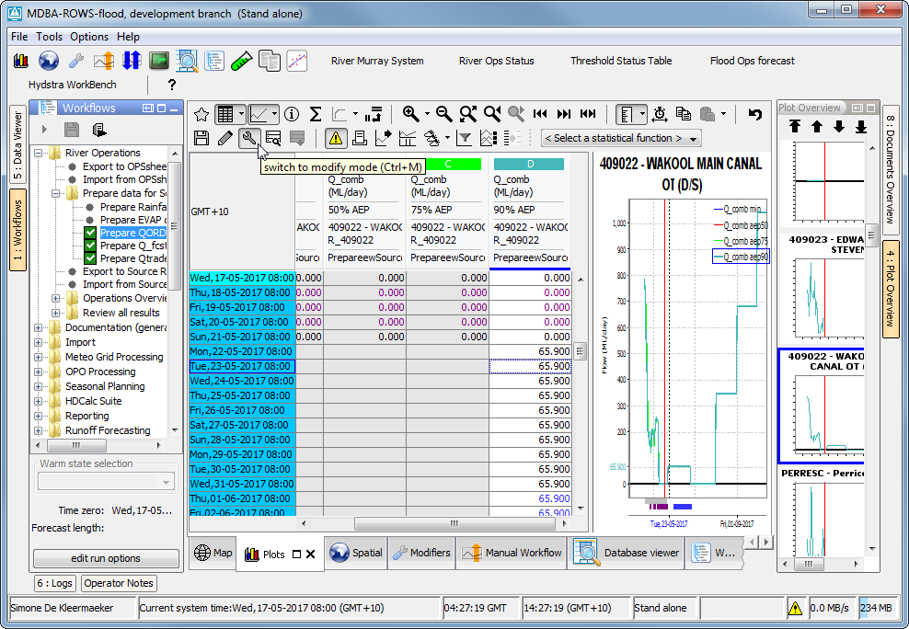

2